Summer Feeding Program

Break for a Plate Alabama

School is out but meals are still available throughout the state of Alabama.
Scan the QR code to locate free meals near you!
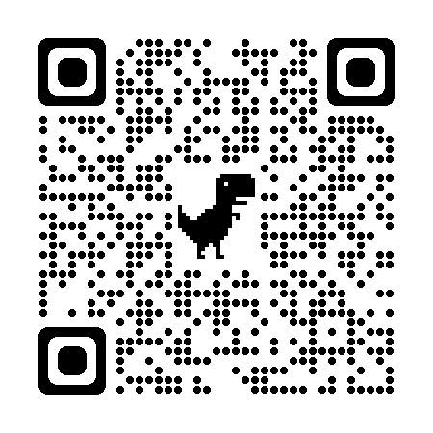

In Accordance with Federal civil rights law and U.S. Department of Agriculture (USDA) civil rights regulations and policies, the USDA, its Agencies, offices, and employees, and institutions participating in or administering USDA programs are prohibited from discriminating based on race, color, national origin, religion, sex. gender identity (including gender expression), sexual orientation, disability. age, marital status. family/parental status, income derived from a public assistance program, political beliefs, or reprisal or retaliation for prior civil rights activity. in any program or activity conducted or funded by USDA (not all bases apply to all programs). Remedies and complaint filing deadlines vary by program or incident.
Persons with disabilities who require alternative means of communication for program information (e.g., Braille, large print, audiotape, American Sign Language, etc.) should contact the responsible Agency or USDA's TARGET Center at (202) 720-2600 (voice and TTY) or contact USDA through the Federal Relay Service at (800) 877-8339. Additionally, program information may be made available in languages other than English.
To file a program discrimination complaint, complete the USDA Program Discrimination Complaint Form, AD-3027, found online at How to File a Program Discrimination Complaint and at any USDA office or write a letter addressed to USDA and provide in the letter all of the information requested in the form. To request a copy of the complaint form, call (866) 632-9992. Submit your completed phone or letter to USDA by: (I) mail: U.S. Department of Agriculture, Office of the Assistant Secretary for Civil Rights. 1400 Independence Avenue, SW, Washington, D.C. 20250-9410; (2) fax: (202) 690-7442; or (3) email: program.intal-.e@usda.gov. USDA is an equal opportunity provider. employer, and lender.

